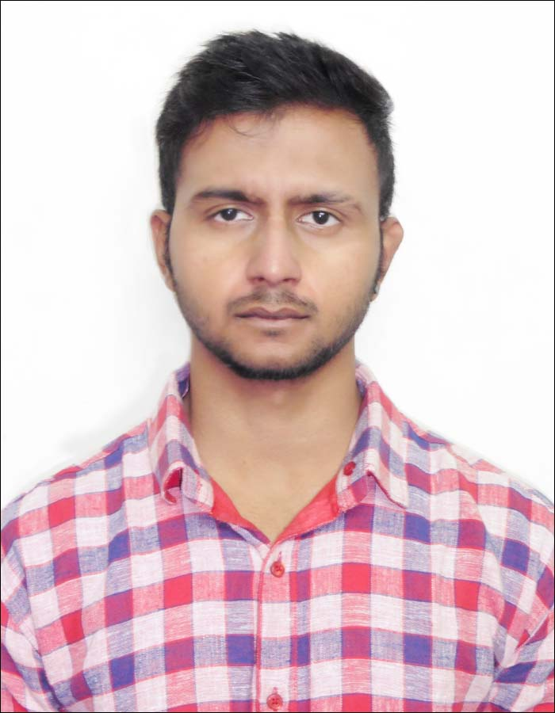  RAJESH KUMAR.DUDALA  Personal Data:  Date of Birth: March 19th,1995  Gender : Male  Nationality : Indian  Contact Details:  7838389412  Current Location:  Gurugram  Correspondence Address:  Sohna Road, Sector 48, Gurugram, Haryana 122018  Permanent Address:  Door num: 41-2-22,Old post office road,Krishna lanka,Vijayawada,  Andhra Pradesh,pin code-520013  E-Mail:  applerajesh007@gmail.com  Linguistic abilities:  English (read, write, speak),  Hindi (read, write and speak),  Telugu (read,write and speak)  Interests :  Web Surfing, gymnaism, creative thinking,  Badminton.  Job experience :  Family Details:  Father Name: Mallikarjuna Rao.D  Mother Name: Sumalatha.D | Objective  To be the part of an organization that will help me to grow and where I can optimally utilize my qualities and qualification in Mass Communication for the betterment of self and of the organization.  PROFESSIONAL EXPERIENCE  - The Hindu , vijayawada  INTERN [June 1- July 31, 2015]  - N2K Computer Education-Administrator , CBE  PART TIME – [Aug 2011-May 2012]  - Jhankaar, Official Student Organization of Lpu  MARKETING MANAGER- [July 2014 – Jan 2015]  OTHER WORKS  - Worked for the News article at THE HINDU and also involved in every department.  - Capstone Project – Magazine titled –FASSIONATE-at LPU  - Done a short film and advertisements. Both audio and video  - Organized various musical events.  - Interacted with the chief editor of the News Paper – The Hindu.  - Also been a part of various Press conferences with celebrities who visited LPU for their movie promotions. Movies like “jal” “jatt jamesbond”  COMPUTER SKILLS  - MS Office  - Corel Draw  - Indesign  - Photoshop  - Adobe After effects  - 3dS max basics  - Fcp 7 & 10  - adobe premiere  ACADEMIC QUALIFICATION  - 10th At Bhashyam Public school  - 12th At Narayana IIT Acadamy  - Bachelors in journalism and mass communication and minor degree of Animation at LPU.  EXTRA CURRICULUM ACTIVITIES  - 2013: co coordinator at One India fest at LPU [  representing Andhra pradesh]  - 2014: co coordinator at One India fest at LPU [ representing Andhra pradesh]  WORKING IN NNIS NEWS AGENCY FROM ONE YEAR AND 4 MONTHS AS AN GRAPHIC DESIGNER AND VIDEO EDITOR  Rajesh kumar.D  November 26, 2017

